Aim
To develop a cloud-based Mark Sheet Processing System using Zoho Creator to store student details, manage subject marks, calculate total marks, average, percentage, rank, and overall performance, demonstrating the Software as a Service (SaaS) model.
Procedure
- Open Zoho Creator and sign in to your account.
- Create a new application named Student Mark Sheet Processing System.
- Create a Student Details form with student name, register number, department, year, and semester
- Create a Mark Entry form with subject name, internal marks, external marks, and maximum marks.
- Create a Mark Sheet Summary form to display total marks, average, percentage, rank, and overall performance.
- Configure formula fields or workflows to calculate total marks, average, and percentage automatically.
- Set grading and pass/fail rules based on the applicable marking scheme.
- Create reports to display student details, subject-wise marks, semester results, and top performers.
- Design a dashboard showing total students, class average, pass/fail counts, and performance charts.
- Enter sample student records and test the application

Implementation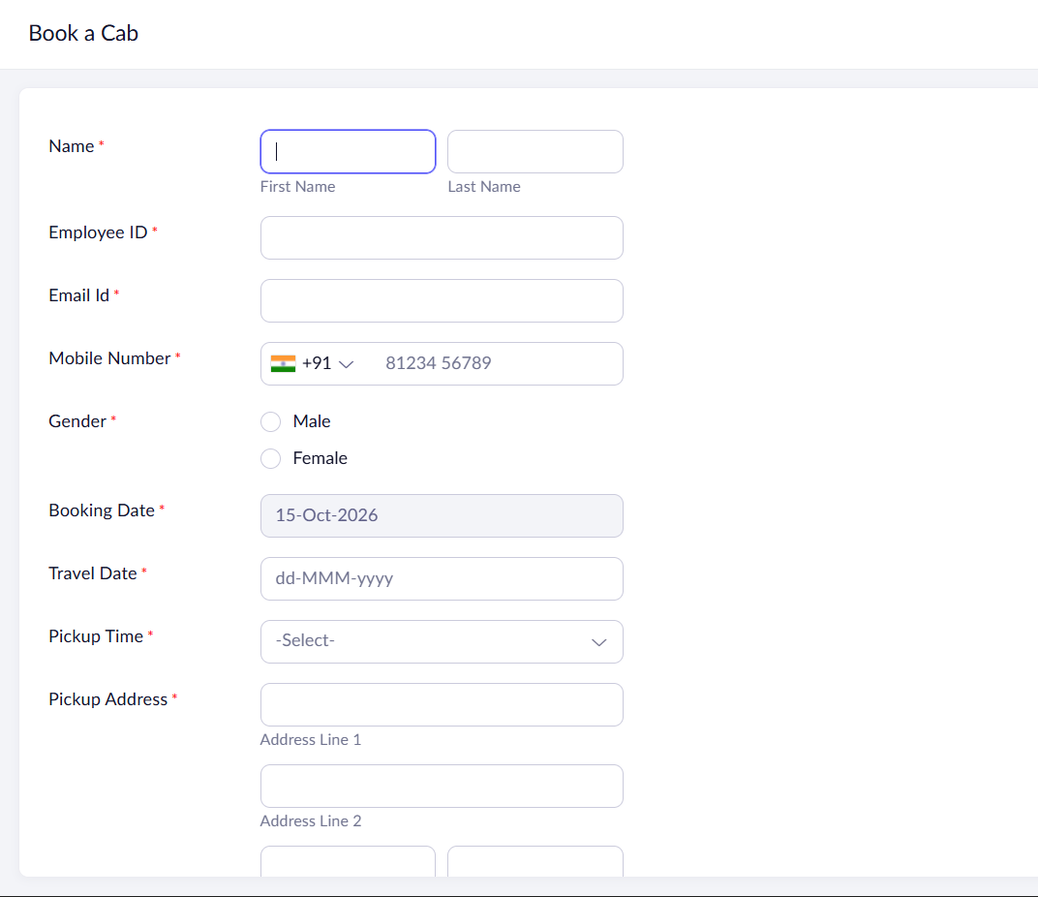
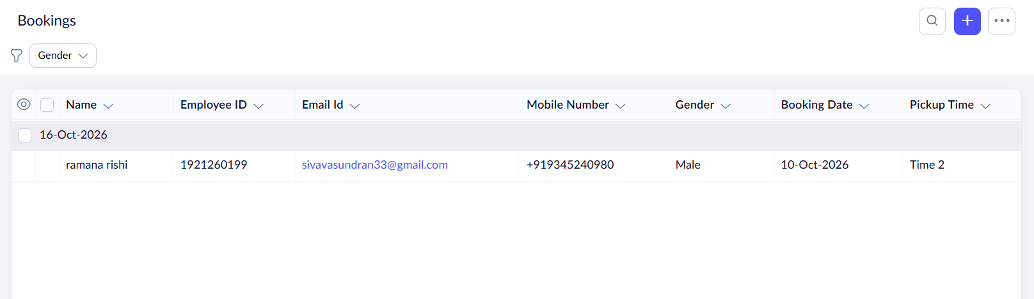
Result:
The Mark Sheet Processing System was successfully designed using Zoho Creator to manage student details, record subject marks, calculate total marks, average, percentage, rank, and overall performance, demonstrating the Software as a Service (SaaS) model.

